**Report Week 2**

**Web Application**

**Lab Report 2 Practice**

**Name: Vũ Lê Minh Đức**

**ID: ITITIU22032**

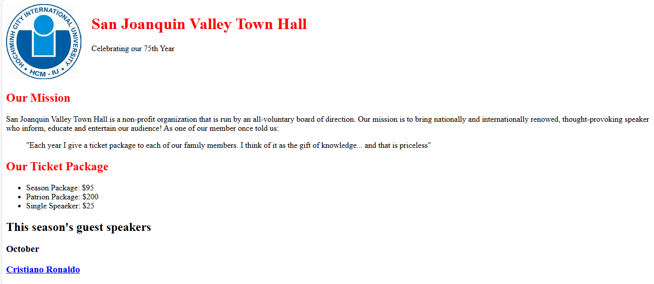

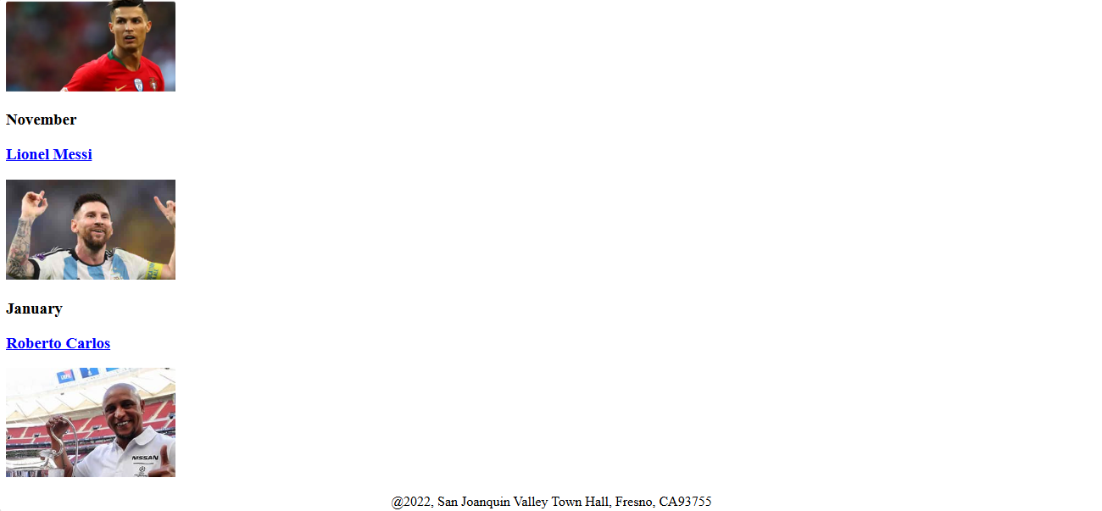

Code of the work:

<!DOCTYPE html>

<html lang="en">

<head>

    <meta charset="UTF-8">

    <meta name="viewport" content="width=device-width, initial-scale=1.0">

    <title>San Joaquin Valley Town Hall</title>

    <link rel="icon" href="image/iu_favi.png" type="image/x-icon">

    <style>

        body{

            background-color: white;

        }

        header{

            display: flex;

        }

        header img{

            width: 150px;

            height: 150px;

        }

        header div{

            margin-left: 20px;

        }

        h1{

            color: red;

        }

        u{

            color: blue;

        }

        footer{

            display: flex;

            justify-content: center;

        }

        main img{

            width: 200px;

        }

    </style>

</head>

<body>

    <header>

        <a href="it.hcmiu.edu.vn"><img src="image/iu_favi.png"></a>

        <div>

        <h1>San Joaquin Valley Town Hall</h1>

        <p>Celebrating our 75th Year</p>

        </div>

    </header>

    <main>

    <section>

        <h1>Our Mission</h1>

        <p>San Joaquin Valley Town Hall is a non-profit organization that is run by an all-voluntary board of direction. Our mission is to bring nationally and internationally renowned,

        thought-provoking speakers who inform, educate and entertain our audience! As one of our members once told us:</p>

        <blockquote>"Each year I give a ticket package to each of our family members.

        I think of it as the gift of knowledge... and that is priceless"</blockquote>

    </section>

    <section>

        <h1>Our Ticket Package</h1>

        <ul>

            <li>Season Package: $95</li>

            <li>Patrion Package: $200</li>

            <li>Single Speaker: $25</li>

        </ul>

    </section>

    <section>

        <h2>This season's guest speakers</h2>

        <h3>October</h3>

        <h3><u>Cristiano Ronaldo</u></h3>

        <img src="image/ronaldo.png">

        <h3>November</h3>

        <h3><u>Lionel Messi</u></h3>

        <img src="image/messi.png">

        <h3>January</h3>

        <h3><u>Roberto Carlos</u></h3>

        <img src="image/roberto.png">

    </section>

    </main>

    <footer>

        <p>@2022, San Joaquin Valley Town Hall, Fresno, CA93755</p>

    </footer>

</body>

</html>